https://rust-embedded.github.io/book/intro/hardware.html

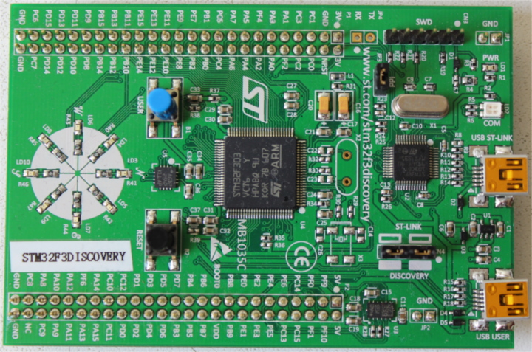

https://rust-embedded.github.io/discovery/

https://github.com/rust-embedded

https://github.com/rust-embedded/awesome-embedded-rust

https://github.com/avr-rust

https://github.com/redox-os/redox

https://github.com/tock/tock

https://github.com/drone-os

https://github.com/hashmismatch/freertos.rs

https://github.com/rust-embedded/rust-raspi3-OS-tutorials

An RTOS for embedded sys-tems in Rust

https://esc.fnwi.uva.nl/thesis/centraal/files/f155044980.pdf

https://techsparx.com/software-development/rust/rust-for-avr-arm-embedded.html

----

一些好玩儿的东西

arduboy

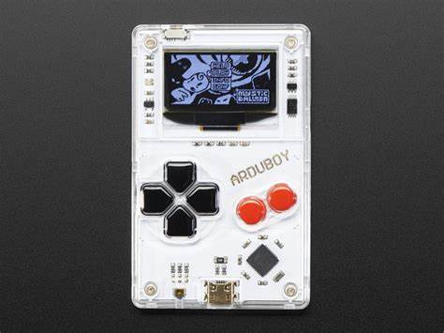

小龙王，掌机

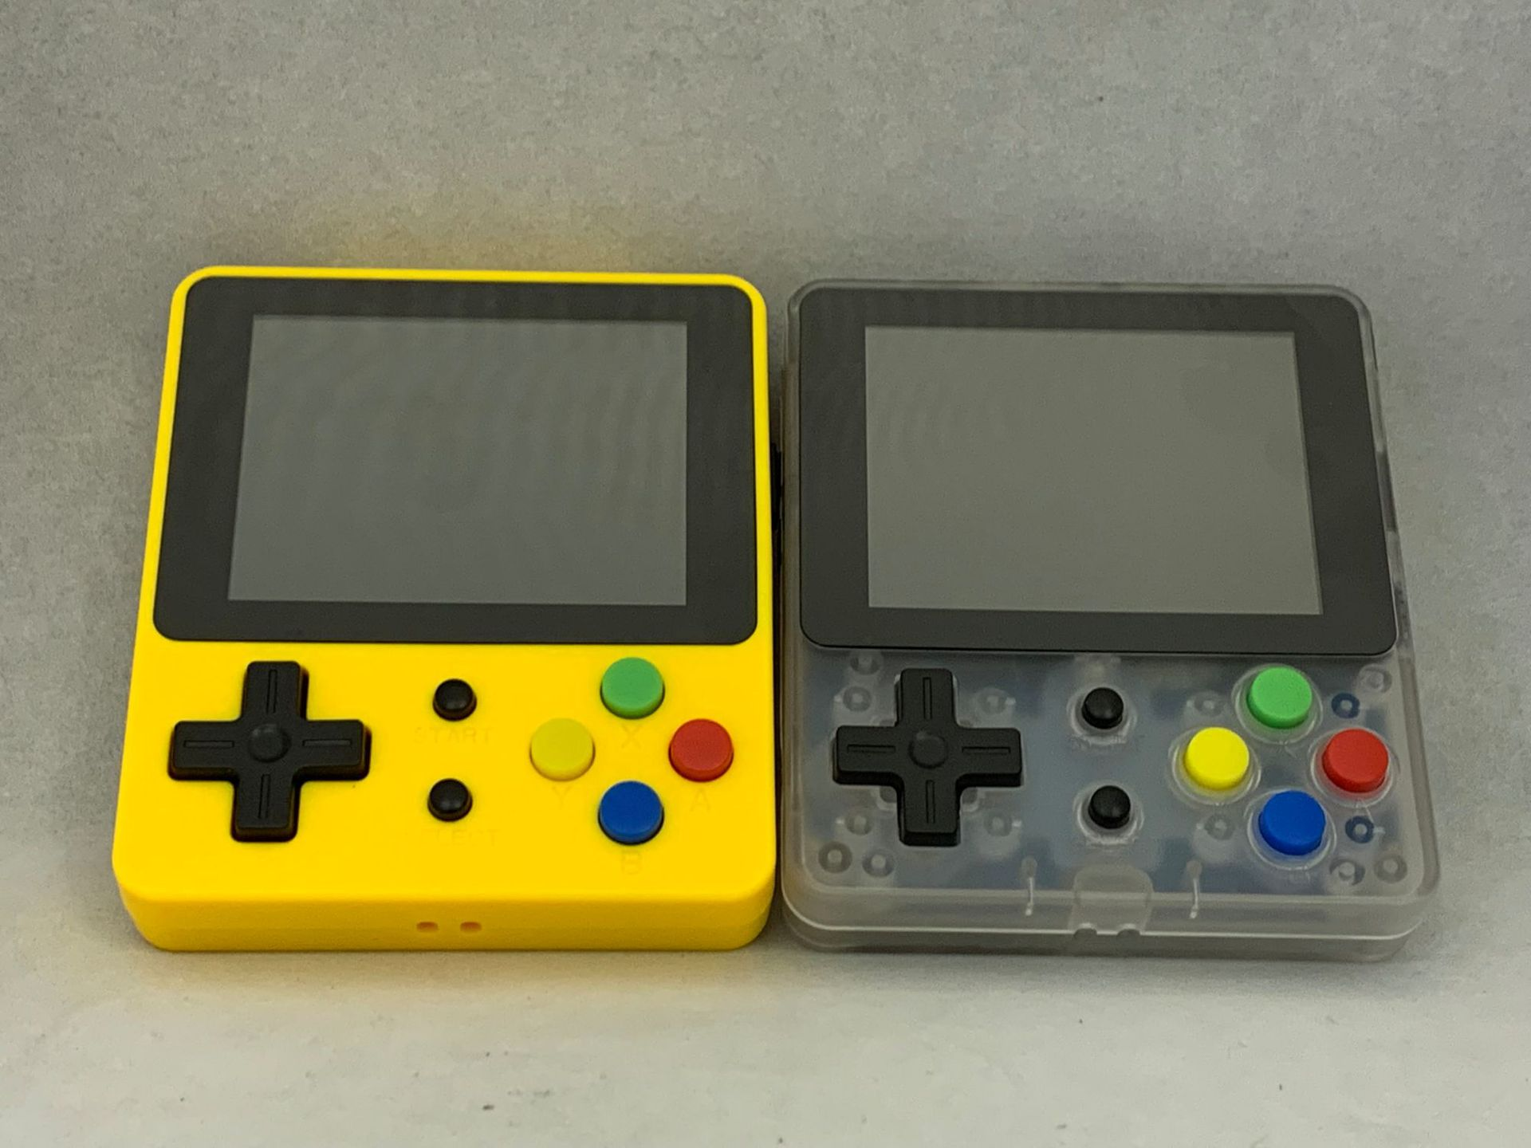

Game Shell

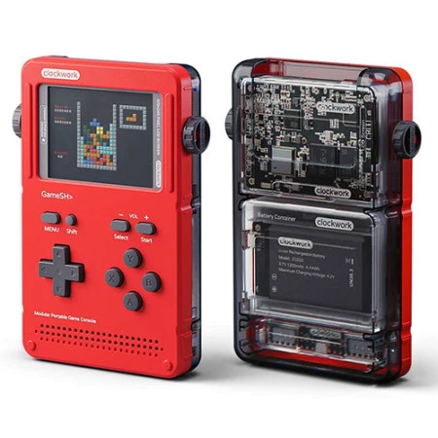

Rephone

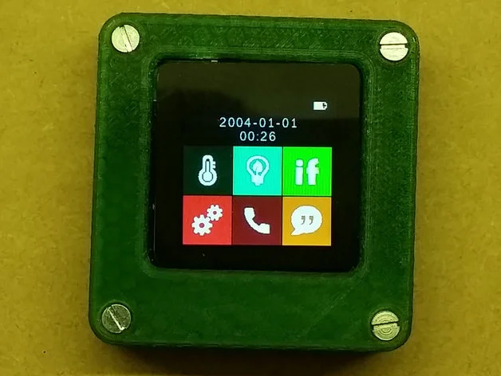

meowbit

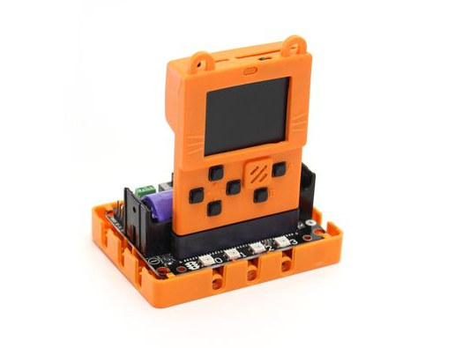

树莓派掌上游戏机

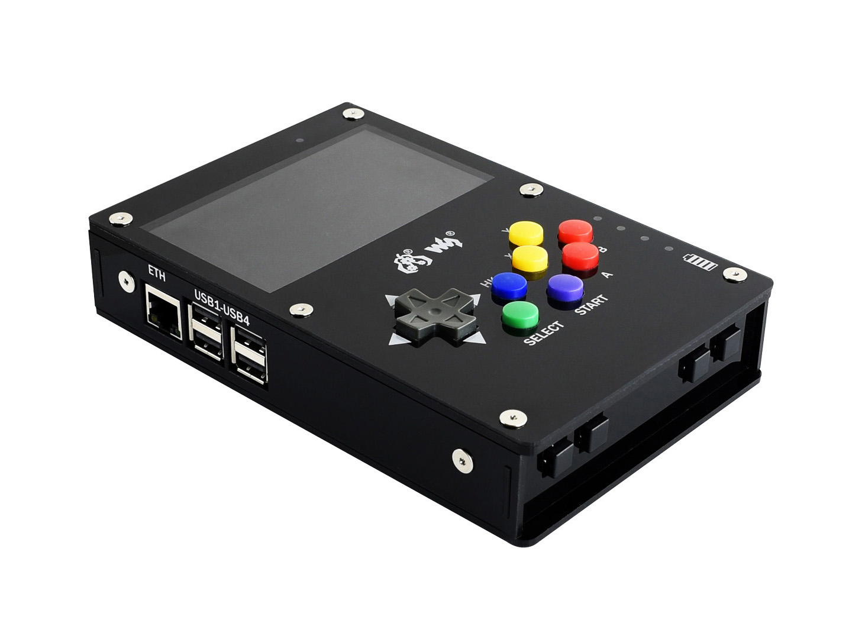

makerphone

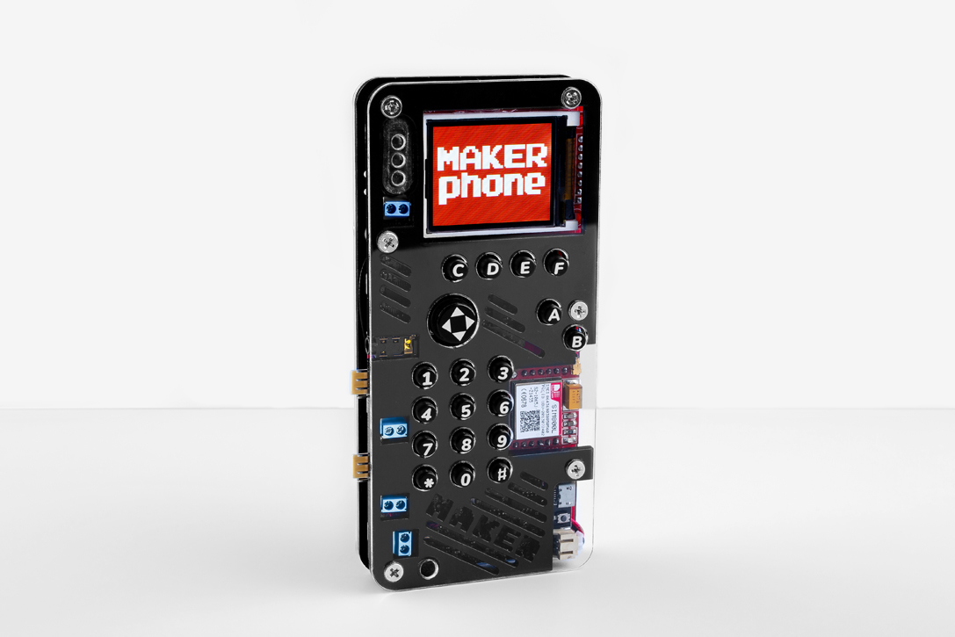

Qin 1s+

